PPS Mini Project

Quiz Game

Done by Rishi Raj Singh (RA2111009010106) & Srihari Sadasivan (RA2111009010238)

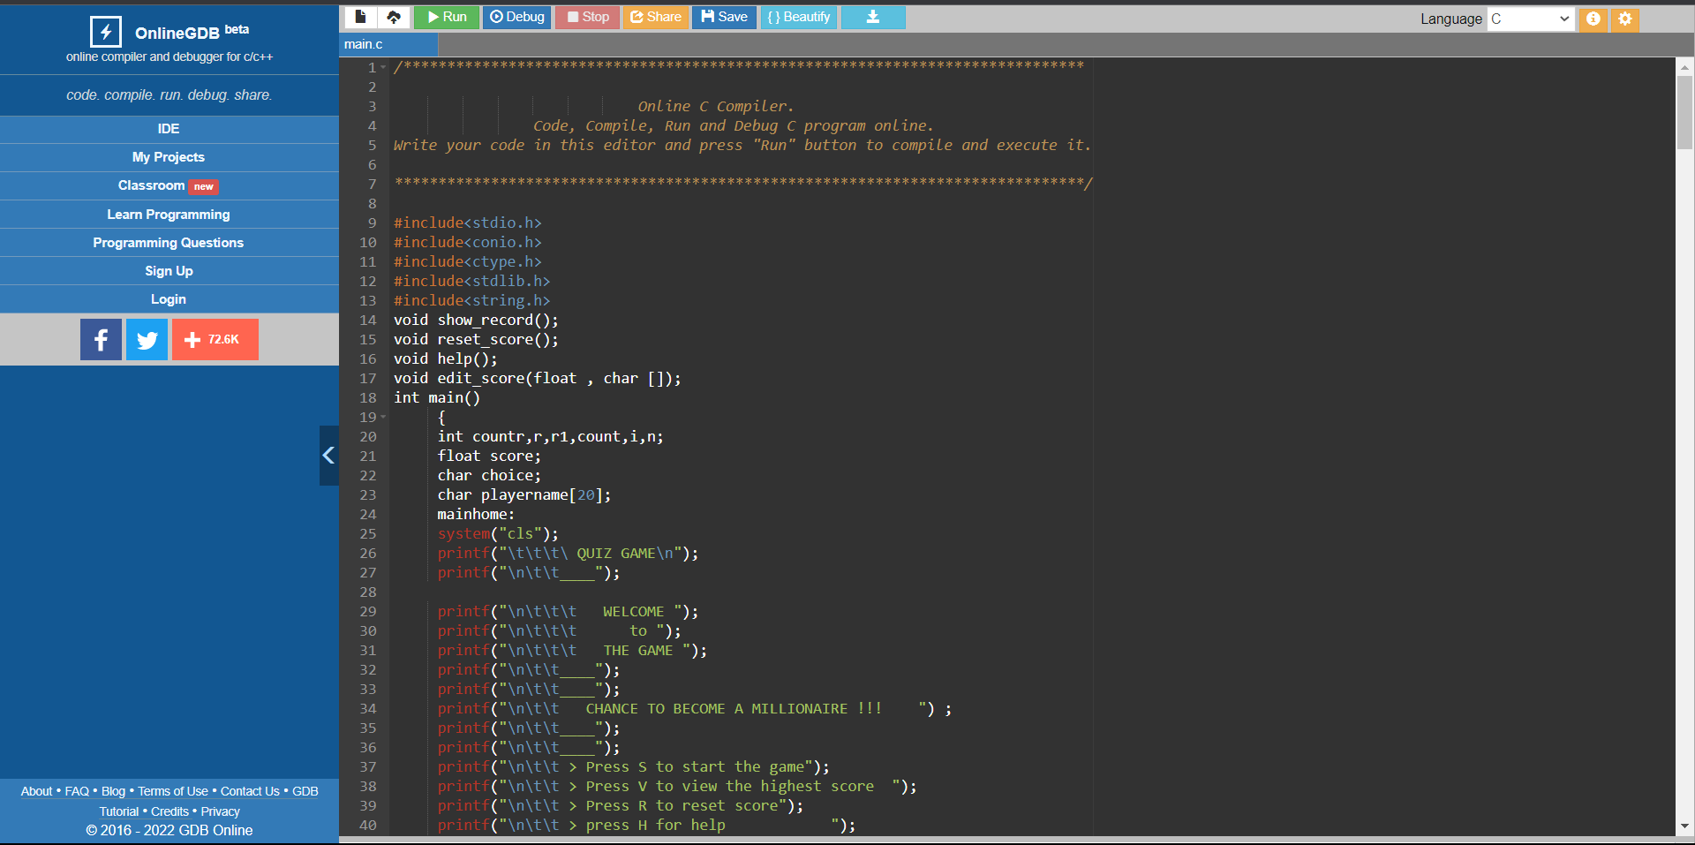

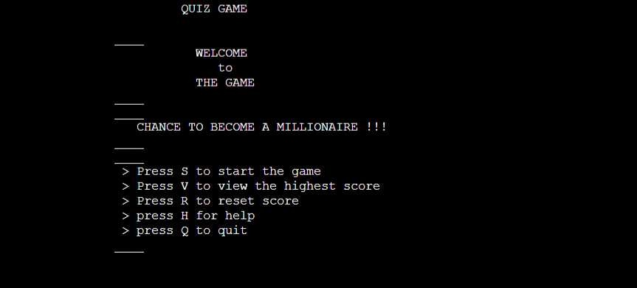

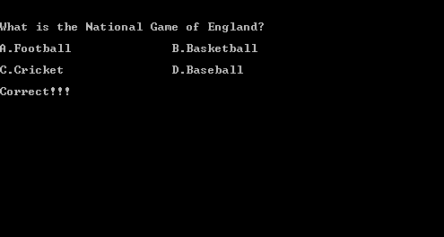

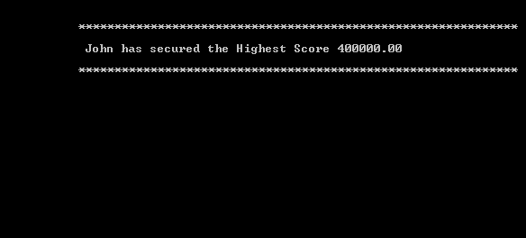

Link: